THE COMMON PORTAL FRAME :

This frame is common to both the user and the admin.

For almost all the frames , we make use of the following import statements:

Import java.sql.*;

import javax.swing.JOptionPane;

import javax.swing.table.DefaultTableModel;

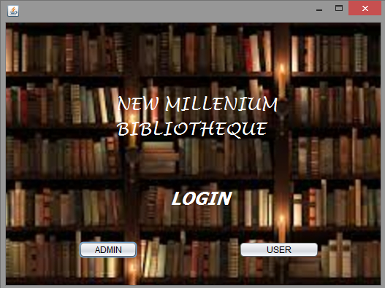

**Code for admin button:**

IP1 adlogin = new IP1();

adlogin.setVisible(false);

IP2_AdminLogin1 page2 = new IP2_AdminLogin1();

page2.setVisible(true);

this.dispose();

**Code for User Button:**

Ipmain login = new Ipmain();

login.setVisible(false);

Ipmain page = new Ipmain();

page.setVisible(true);

this.dispose();

USER SECTION

This frame takes in the user name and password of the user, incase, the user is not an existing member, he or she can become a new member by signing up for free.

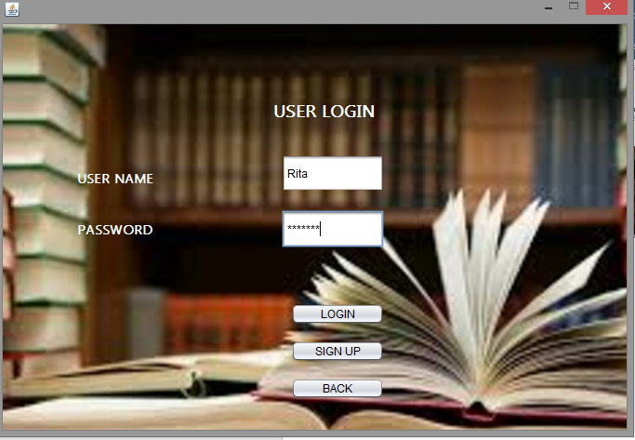

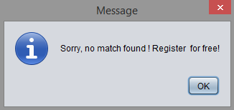

CODE FOR LOGIN BUTTON:

String uname = jTextField1.getText();

String pass = new String(jPasswordField1.getPassword());

System.out.println(pass);

try{

Class.forName("java.sql.Driver");

Connection con= DriverManager.getConnection("jdbc:mysql://localhost:3306/library_12a","root","");

Statement stmt = con.createStatement();

String query ="select uname,pswd from user_records;";

System.out.println(query);

ResultSet rs= stmt.executeQuery(query);

String DBuname;

String DBpswd;

boolean lflag= false;

while(rs.next())

{

DBuname=rs.getString(1);

DBpswd=rs.getString(2);

if(uname.equals(DBuname) && pass.equals(DBpswd))

{lflag=true;

JOptionPane.showMessageDialog(null,"You have sucessfully logged in");

Ipmain login = new Ipmain();

login.setVisible(false);

IPUserData1 user = new IPUserData1();

user.setVisible(true);

this.dispose()

}

}

if(lflag==false){

JOptionPane.showMessageDialog(null,"Sorry, no match found ! Register for free!");

}}

catch(Exception e){

}

}

private void jButton1ActionPerformed(java.awt.event.ActionEvent evt) {

Ipmain login = new Ipmain();

login.setVisible(false);

IP3signUp1 signup = new IP3signUp1();

signup.setVisible(true);

this.dispose();

}

private void jButton3ActionPerformed(java.awt.event.ActionEvent evt) {

Ipmain login1 = new Ipmain();

login1.setVisible(false);

IP1 main1 = new IP1();

main1.setVisible(true);

this.dispose()

}

Code for Sign Up button:

Ipmain login = new Ipmain();

login.setVisible(false);

IP3signUp1 signup = new IP3signUp1();

signup.setVisible(true);

this.dispose();

Code for back button:

Ipmain login1 = new Ipmain();

login1.setVisible(false);

IP1 main1 = new IP1();

main1.setVisible(true);

this.dispose();

REGISTRATION

An unregistered user is directed to this page on the click of the Register button. The field marked with a * are mandatory to be filled.

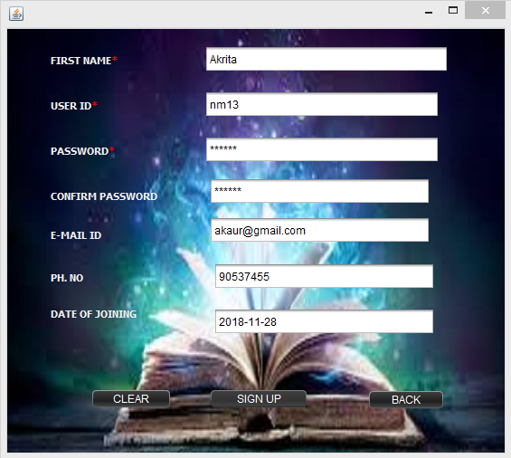

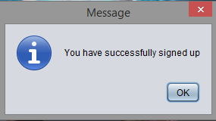

Code for Sign Up button:

String uid =jTextField8.getText();

String uname = jTextField1.getText();

String pswd = new String(jPasswordField1.getPassword());

String pswd2 = new String(jPasswordField2.getPassword());

String email = jTextField3.getText();

String phno = jTextField4.getText();

String jdate= jTextField7.getText();

if(uid.equals("")||uname.equals("")||pswd.equals("")||pswd2.equals(""))

{

JOptionPane.showMessageDialog(null,"Please enter required details");

}

else{

if (pswd2.equals(pswd)){

try{

Class.forName("java.sql.Driver");

Connection con= DriverManager.getConnection("jdbc:mysql://localhost:3306/library_12a","root","");

Statement stmt = con.createStatement();

String query = "insert into user_records values ('" +uid+ "','" +uname+ "','" +pswd+ "','"+email+"','"+phno+"','"+jdate+"','nil');";

System.out.println(query);

int succ= stmt.executeUpdate(query);

if(succ>0){

JOptionPane.showMessageDialog(null,"You have successfully signed up");

}

else{

JOptionPane.showMessageDialog(null,"Please try again ");

}

}

catch(Exception e){

System.out.println(e);}

}

else {

JOptionPane.showMessageDialog(null,"Please try again the passwords do not match !!!!!!");}

}

}

Code for clear button:

jTextField1.setText(" ");

jTextField4.setText(" ");

jTextField3.setText(" ");

jTextField8.setText(" ");

jTextField7.setText(" ");

jPasswordField1.setText("");

jPasswordField2.setText("");

Code for back button:

IP3signUp1 back = new IP3signUp1();

back.setVisible(false);

Ipmain diff = new Ipmain();

diff.setVisible(true);

this.dispose();

FOR REGISTERED OR EXISTING USERS:

An existing user will be redirected to the user’s main portal. A JOptionPane message dialog will be used to display if the user has logged on .

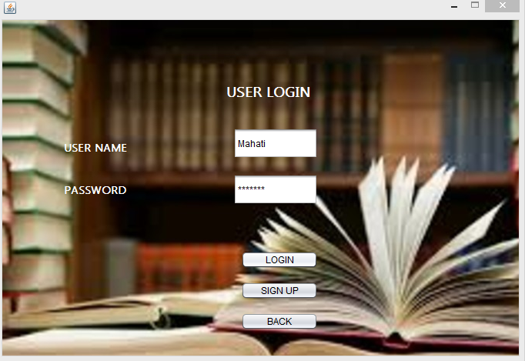

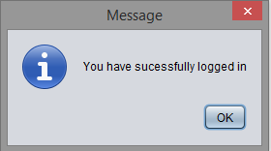

USER GATEWAY

The user gateway leads the user to explore the library under two broad options. A user can edit his or her profile , or can even check out the latest books.

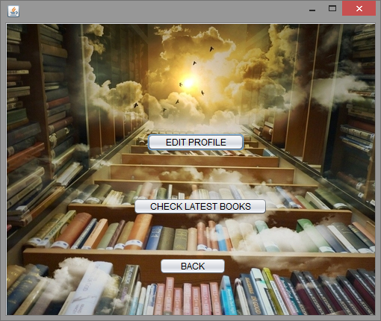

Code for edit profile button :

IPUserData1 ep = new IPUserData1();

ep.setVisible(false);

Editprofile ep1 = new Editprofile();

ep1.setVisible(true);

this.dispose();

Code for Check latest books button :

IPUserData1 udata = new IPUserData1();

udata.setVisible(false);

IPUserLatestBooks1 latest= new IPUserLatestBooks1();

latest.setVisible(true);

this.dispose();

Code for back button :

IPUserData1 ud1 = new IPUserData1();

ud1.setVisible(false);

Ipmain main2 = new Ipmain();

main2.setVisible(true);

this.dispose();

EDIT PROFILE

This frame allows the user to change his or her password, e-mail or phone number which are accordingly changed in the tables. If a user wishes to change only one of the three field, that can be done too.

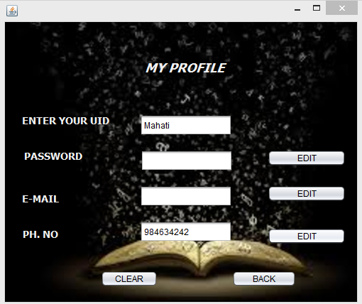

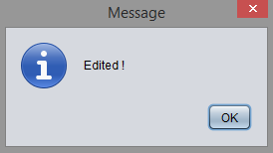

Code for Editing Password Button:

String uid= jTextField1.getText();

String pwd= new String(jPasswordField1.getPassword());

try{

if(uid.length()>0)

{

Class.forName("java.sql.Driver");

Connection con= DriverManager.getConnection("jdbc:mysql://localhost:3306/library_12a","root","");

Statement stmt = con.createStatement();

if(pwd.length()>0){

String query1 = "update user_records set pswd= '" +pwd+ "'where uid = '"+uid+"';";

System.out.println(query1);

int r = stmt.executeUpdate(query1);

}

}

}

catch(Exception e){

System.out.println(e);

}

Code for editing e-mail button :

String uid= jTextField1.getText();

String mail= jTextField3.getText();

try{

if(uid.length()>0)

{

Class.forName("java.sql.Driver");

Connection con= DriverManager.getConnection("jdbc:mysql://localhost:3306/library_12a","root","");

Statement stmt = con.createStatement();

if(mail.length()>0){

String query2 = "update user_records set email= '" +mail+ "'where uid = '"+uid+"';";

System.out.println(query2);

int r = stmt.executeUpdate(query2);

}

}

}

catch(Exception e){

System.out.println(e);

}

Code for editing phone number button :

String uid= jTextField1.getText();

int phno= Integer.parseInt(jTextField4.getText());

try{

if(uid.length()>0)

{

Class.forName("java.sql.Driver");

Connection con= DriverManager.getConnection("jdbc:mysql://localhost:3306/library_12a","root","");

Statement stmt = con.createStatement();

if(String.valueOf(phno).length()>0){

String query3 = "update user_records set phone = " +phno+ " where uid = '"+uid+"';";

System.out.println(query3);

int r = stmt.executeUpdate(query3);

JOptionPane.showMessageDialog(null, "Edited !");

}

}

}

catch(Exception e){

System.out.println(e);

}

Code for clear button :

jTextField1.setText(" ");

jTextField3.setText(" ");

jTextField4.setText(" ");

jPasswordField1.setText(" ");

Code for back button :

Editprofile user = new Editprofile();

user.setVisible(false);

IPUserData1 main3 = new IPUserData1();

main3.setVisible(true);

this.dispose();

CHECK LATEST BOOKS

This portal allows the user to explore the available range of books which are shown in the jTable control.

Search can be filtered or sorted by book title, author or the publisher.

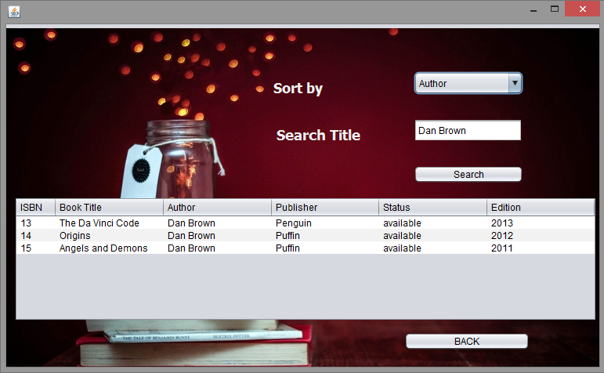

Code for search button :

String sort = jTextField1.getText();

String choose = jComboBox1.getSelectedItem().toString();

try{

Class.forName("java.sql.Driver");

Connection con= DriverManager.getConnection("jdbc:mysql://localhost:3306/library_12a","root","");

Statement stmt = con.createStatement();

String query ="select ISBN,Book_Title,Author,Publisher, Status,edition from book1 where "+choose+" like '%"+sort+"%' order by "+choose+";";

System.out.println(query);

ResultSet rs= stmt.executeQuery(query);

DefaultTableModel dm= (DefaultTableModel)jTable1.getModel();

while(rs.next()){

String isbn=rs.getString(1);

String bTitle=rs.getString(2);

String author=rs.getString(3);

String pulisher=rs.getString(4);

String stat=rs.getString(5);

String edi=rs.getString(6);

dm.addRow(new Object[] {isbn,bTitle,author,pulisher,stat,edi});

}

}

catch(Exception e){

System.out.println(e);

}

Code for back button :

IPUserLatestBooks1 user1 = new IPUserLatestBooks1();

user1.setVisible(false);

IPUserData1 main3 = new IPUserData1();

main3.setVisible(true);

this.dispose();

ADMIN SECTION

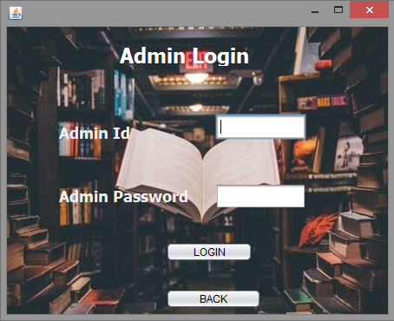

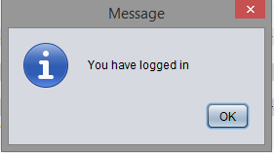

Code for login button :

String str1=jTextField1.getText();

String passad = new String(jPasswordField1.getPassword());

if (str1.equals("admin")&&passad.equals("admin234")){

JOptionPane.showMessageDialog(null," You have logged in");

IP2_AdminLogin1 adm = new IP2_AdminLogin1();

adm.setVisible(false);

IP2LoginNext1 next = new IP2LoginNext1();

next.setVisible(true);

this.dispose();

}

else {

JOptionPane.showMessageDialog(null," Sorry, wrong password or username!");

}

Code for back button:

IP2_AdminLogin1 login2 = new IP2_AdminLogin1();

login2.setVisible(false);

IP1 main = new IP1();

main.setVisible(true);

this.dispose();

ADMIN’S PORTAL :

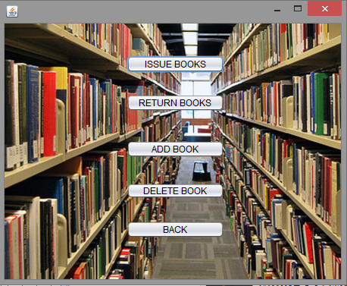

Code for Issue books button :

IP2LoginNext1 main5 = new IP2LoginNext1();

main5.setVisible(false);

IPMemberBookIssue1 issue1 = new IPMemberBookIssue1();

issue1.setVisible(true);

this.dispose();

Code for Return books button :

IP2LoginNext1 main6 = new IP2LoginNext1();

main6.setVisible(false);

ReturnBook issue5 = new ReturnBook();

issue5.setVisible(true);

this.dispose();

Code for add book button ;

IP2LoginNext1 bc1 = new IP2LoginNext1();

bc1.setVisible(false);

BookConsole12 bc2 = new BookConsole12();

bc2.setVisible(true);

this.dispose();

Code for Delete book button :

IP2LoginNext1 bc1 = new IP2LoginNext1();

bc1.setVisible(false);

DeleteBook db = new DeleteBook();

db.setVisible(true);

this.dispose();

Code for back button :

IP2LoginNext1 ln2 = new IP2LoginNext1();

ln2.setVisible(false);

IP2_AdminLogin1 al1 = new IP2_AdminLogin1();

al1.setVisible(true);

this.dispose();

ISSUE BOOKS:

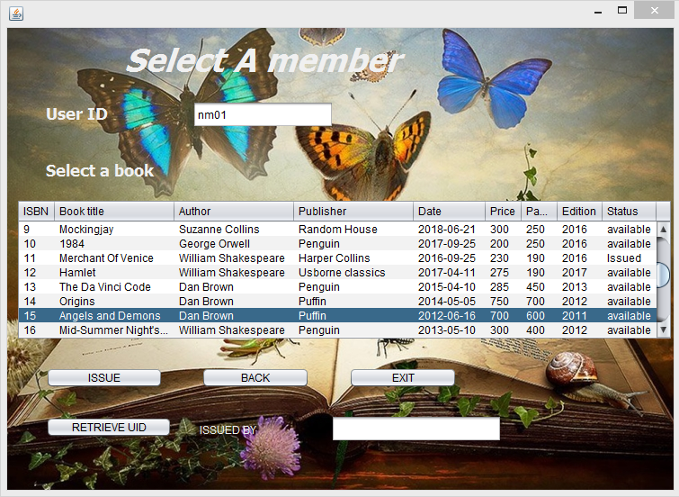

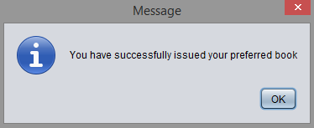

THE ADMIN CAN ALSO RETRIEVE THE USER ID OF THE PERSON WHO HAS ISSUED A BOOK FROM THE TABLE.

Code for Issue book button :

DefaultTableModel myTable1= ( DefaultTableModel)jTable1.getModel();

int row= jTable1.getSelectedRow();

int col=jTable1.getSelectedColumn();

String uid = jTextField1.getText().trim();

String val=(String)myTable1.getValueAt(row,0).toString();

try{

Class.forName("java.sql.Driver");

Connection con=DriverManager.getConnection("jdbc:mysql://localhost:3306/library_12a","root","");

Statement stmt=con.createStatement();

if(uid.length()>0)

{

System.out.println(val);

String sp=(String)myTable1.getValueAt(row,8);

if(sp.equals("Issued")){

JOptionPane.showMessageDialog(null, "Sorry, this book has already been issued ");

}

else{

String str="update book1 set status= 'Issued' where ISBN="+val+";";

System.out.println(str);

int rs=stmt.executeUpdate(str); }}

else

{

JOptionPane.showMessageDialog(null, "Please Enter UID")

}

}

catch(Exception e){

}

try{

Class.forName("java.sql.Driver");

Connection con=DriverManager.getConnection("jdbc:mysql://localhost:3306/library_12a","root","");

String sn=(String)myTable1.getValueAt(row,1);

Statement stmt=con.createStatement();

if(uid.length()>0){

String str2="update user_records set curbook = '" +sn+" ' where uid='"+uid+"';";

int rs2=stmt.executeUpdate(str2);

JOptionPane.showMessageDialog(null, "You have successfully issued your preferred book");

}

}

catch(Exception e){

}

Code for back button:

IPMemberBookIssue1 issue1 = new IPMemberBookIssue1();

issue1.setVisible(false);

IP2LoginNext1 main4 = new IP2LoginNext1();

main4.setVisible(true);

this.dispose();

Code for exit button:

System.exit(0);

Code for Retrieve UID button:

DefaultTableModel myTable1= ( DefaultTableModel)jTable1.getModel();

int row= jTable1.getSelectedRow();

int col=jTable1.getSelectedColumn();

String val=(String)myTable1.getValueAt(row,0).toString();

try{

Class.forName("java.sql.Driver");

Connection con=DriverManager.getConnection("jdbc:mysql://localhost:3306/library_12a","root","");

Statement stmt=con.createStatement();

System.out.println(val);

String spf=(String)myTable1.getValueAt(row,1);

String shr= "Select uid from user_records where curbook= '"+ spf+"';";

ResultSet r2=stmt.executeQuery(shr);

r2.next();

System.out.println( r2.getString(1));

jTextField2.setText("" + r2.getString(1));

}

catch(Exception e){

}

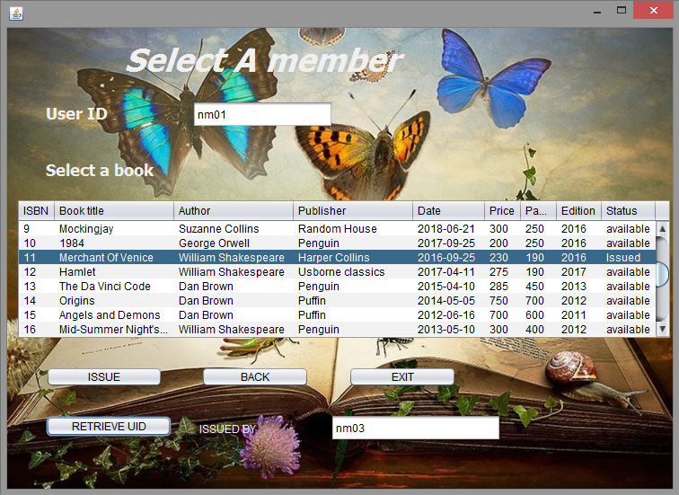

RETURN BOOKS

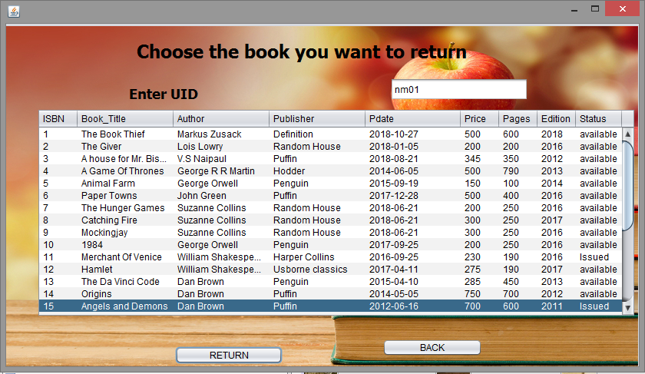

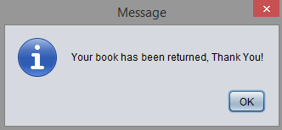

Code for return button:

DefaultTableModel myTable1= ( DefaultTableModel)jTable1.getModel();

int row= jTable1.getSelectedRow();

int col=jTable1.getSelectedColumn();

String str6=jTextField1.getText().trim();

String val5=(String)myTable1.getValueAt(row,0).toString();

try{

Class.forName("java.sql.Driver");

Connection con=DriverManager.getConnection("jdbc:mysql://localhost:3306/library_12a","root","");

Statement stmt=con.createStatement();

System.out.println(val5);

String sp=(String)myTable1.getValueAt(row,8);

if(str6.length()>0)

{

if(sp.equals("Issued")){

JOptionPane.showMessageDialog(null, "Your book has been returned, Thank You! ");

String str="update book1 set status= 'available' where ISBN="+val5+";";

System.out.println(str);

int rs=stmt.executeUpdate(str);

}

}

else

{

JOptionPane.showMessageDialog(null,"Please enter your UID");

}

}

catch(Exception e){

}

try{

Class.forName("java.sql.Driver");

Connection con=DriverManager.getConnection("jdbc:mysql://localhost:3306/library_12a","root","");

String sn=(String)myTable1.getValueAt(row,1);

Statement stmt=con.createStatement();

if(str6.length()>0)

{

String str5="update user_records set curbook = 'Nil ' where uid='"+str6+"';";

int rs2=stmt.executeUpdate(str5); }

}

catch(Exception e){

}

}

private void jButton2ActionPerformed(java.awt.event.ActionEvent evt) {

ReturnBook issue2 = new ReturnBook();

issue2.setVisible(false);

IP2LoginNext1 main5 = new IP2LoginNext1();

main5.setVisible(true);

this.dispose();

}

Code for back button:

ReturnBook issue2 = new ReturnBook();

issue2.setVisible(false);

IP2LoginNext1 main5 = new IP2LoginNext1();

main5.setVisible(true);

this.dispose();

ADD BOOK

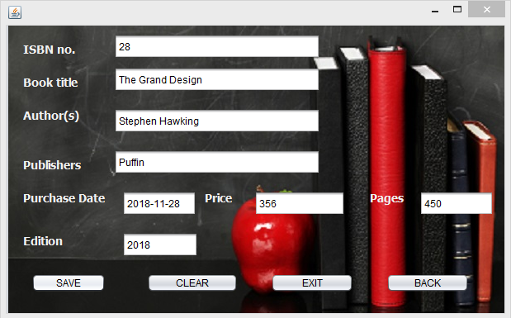

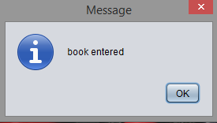

Code for save button:

int ISBN = Integer.parseInt(jTextField1.getText());

String BT = jTextField2.getText();

String author = jTextField3.getText();

String pub = jTextField4.getText();

String pdate = jTextField5.getText();

double price = Double.parseDouble(jTextField6.getText());

int pages = Integer.parseInt(jTextField7.getText());

String edition = jTextField8.getText();

if(ISBN==' '||BT.equals("")||author.equals("")||pub.equals("")||pdate.equals("")||price==' '||pages==' '||edition.equals(""))

{

JOptionPane.showMessageDialog(null,"Please enter required details");

}

else{

try{

Class.forName("java.sql.Driver");

Connection con= DriverManager.getConnection("jdbc:mysql://localhost:3306/library_12a","root","");

Statement stmt = con.createStatement();

String query = "insert into book1 values("+ISBN+",'"+BT+ "','" +author+ "','"+pub+"','"+pdate+"',"+price+","+pages+",'"+edition+"','available');";

System.out.println(query);

int succ= stmt.executeUpdate(query);

if(succ>0){

JOptionPane.showMessageDialog(null,"book entered");

}

else{

JOptionPane.showMessageDialog(null,"Please try again ");

}

}

catch(Exception e){

System.out.println(e);

}

}

}

Code for clear button:

jTextField1.setText("");

jTextField2.setText("");

jTextField3.setText("");

jTextField4.setText("");

jTextField5.setText("");

jTextField6.setText("");

jTextField7.setText("");

jTextField8.setText("");

Code for exit button:

System.exit(0);

Code for back button:

BookConsole12 bc1 = new BookConsole12();

bc1.setVisible(false);

IP2LoginNext1 ln1 = new IP2LoginNext1();

ln1.setVisible(true);

this.dispose();

DELETE BOOK

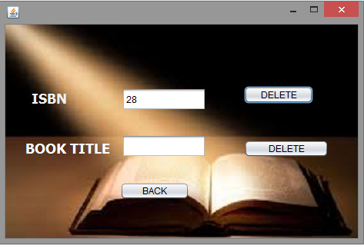

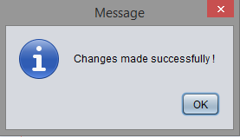

Code for delete ISBN button:

int ISBN = Integer.parseInt(jTextField1.getText());

String name = jTextField2.getText();

try{

Class.forName("java.sql.Driver");

Connection con= DriverManager.getConnection("jdbc:mysql://localhost:3306/library_12a","root","");

Statement stmt = con.createStatement();

String query4="delete from book1 where isbn ="+ISBN+";";

int rs=stmt.executeUpdate(query4);

JOptionPane.showMessageDialog(null,"Changes made successfully !");

}

catch(Exception e){

System.out.println(e);

}

Code for delete book title button:

String name = jTextField2.getText();

try{

Class.forName("java.sql.Driver");

Connection con= DriverManager.getConnection("jdbc:mysql://localhost:3306/library_12a","root","");

Statement stmt = con.createStatement();

String query4="delete from book1 where Book_Title = '"+name+"';";

int rs=stmt.executeUpdate(query4);

JOptionPane.showMessageDialog(null,"Changes made successfully !");

}

catch(Exception e){

System.out.println(e);

}

Code for back button:

IP2LoginNext1 bc1 = new IP2LoginNext1();

bc1.setVisible(true);

DeleteBook db = new DeleteBook();

db.setVisible(false);

this.dispose();